NAME – GAURI CHAUHAN
CLASS - BCA 111 C
ROLL NO 24/SCA/BCAaiml/020
Subject – Python lab file

Ques 1 write a python programme to calculate no of days between two dates . sample dates (2014,7,2).(2014,7,11)
Expected output : 9 days

from datetime import date

# Sample dates date1 = date(2014, 7, 2) date2 = date(2014, 7, 11) # Calculate difference difference = date2 - date1

# Print result
print(f"{difference.days} days")
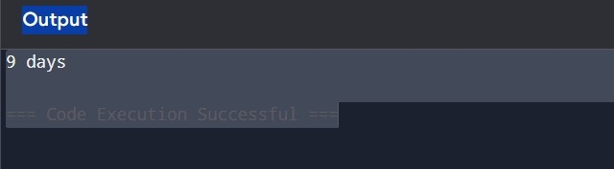
Ques 2 Ask the user for a number . depending on whether the number is even or odd, print out an appopriate message to the user.
# Ask the user to enter a number num = int(input("Enter a number: "))

# Check if the number is even or odd if num % 2 == 0:
print("The number is even.") else:
print("The number is odd.")
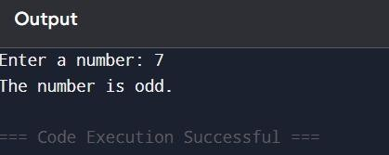
Ques 3 Write a python programme to calculate the sum of three given numbers ,if the values are equal then return thrice of their sum.
# Ask the user to enter three numbers a = int(input("Enter first number: ")) b = int(input("Enter second number: ")) c = int(input("Enter third number: "))

# Check if all numbers are equal if a == b == c:
result = 3 * (a + b + c) else:
result = a + b + c

# Print the result
print("Result:", result)
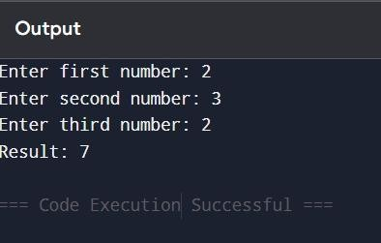
Ques 4 write a python programme to calculate numbers of days between two dates.
rom datetime import date

# Ask the user to enter the first date year1 = int(input("Enter the first year: ")) month1 = int(input("Enter the first month: ")) day1 = int(input("Enter the first day: "))

# Ask the user to enter the second date year2 = int(input("Enter the second year: ")) month2 = int(input("Enter the second month: ")) day2 = int(input("Enter the second day: "))

# Create date objects date1 = date(year1, month1, day1) date2 = date(year2, month2, day2)

# Calculate the difference difference = abs((date2 - date1).days)

# Print the number of days
print("Number of days between the two dates:", difference)
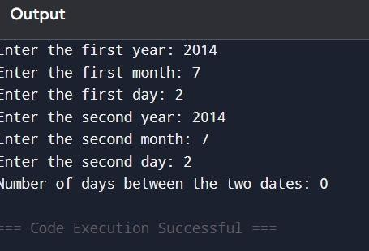
Ques 5 write a python programme to test whether a passed letter is vowel or not.
# Ask the user to enter a letter letter = input("Enter a letter: ")

# Convert to lowercase to handle both uppercase and lowercase letter = letter.lower()

# Check if the letter is a vowel if letter in ('a', 'e', 'i', 'o', 'u'):
print("It is a vowel.") else: print("It is not a vowel.")
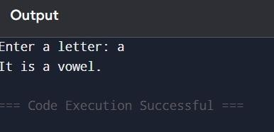
Ques 6 Take a list , say for example this one:
A=[1,1,2,3,5,8,13,21,34,55,89] and write programme that prints out all elements of the list that are less than 5 .
# Given list
A = [1, 1, 2, 3, 5, 8, 13, 21, 34, 55, 89]

# Print elements less than 5 for number in A: if number < 5:
print(number)
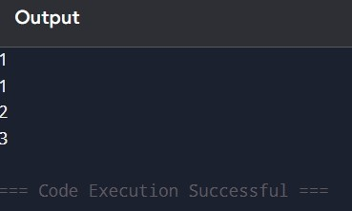
Ques 7 Ask the user for a string and print out whether this string is a palindrome or not.( a palidronme isa a string that reads the same forwars and backwards.)
# Ask the user to enter a string text = input("Enter a string: ") # Remove spaces and convert to lowercase for proper comparison
clean_text = text.replace(" ", "").lower()

# Check if the string is equal to its reverse if clean_text == clean_text[::-1]: print("This is a palindrome.") else: print("This is not a palindrome.")
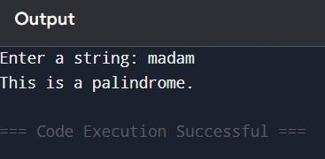
Ques 8 Ask the user for a number and determine whether the number is prime or not .(for those who have forgotten , a prime number is a number that has no divisors. # Ask the user to enter a number num = int(input("Enter a number: "))

# Prime check
if num <= 1:
print("This is not a prime number.") else:
is_prime = True for i in range(2, int(num**0.5) + 1):
if num % i == 0: is_prime = False break

if is_prime:
print("This is a prime number.") else: print("This is not a prime number.")
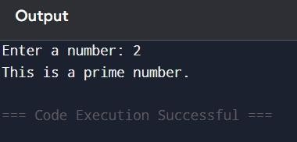
Ques 9 Write a programme to remove all duplicate elements from a list nums=[1,2,2,3,4,4,5] and print the unique list in ascending order.
# Given list with duplicates nums = [1, 2, 2, 3, 4, 4, 5]

# Remove duplicates using set, then sort the result unique_nums = sorted(set(nums))

# Print the unique sorted list
print("Unique list in ascending order:", unique_nums)
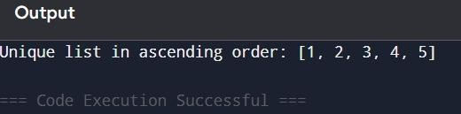
QUES 10 Given a list fruits =[‘apple’, ’banana’, ’apple’, ’orange’, ’banana’, ’apple’], write a programme to count the occurrence of each fruit of each fruit and store it in a dictionary.
# Given list
fruits = ['apple', 'banana', 'apple', 'orange', 'banana', 'apple']

# Create an empty dictionary to store counts fruit_count = {}

# Count occurrences for fruit in fruits:
if fruit in fruit_count: fruit_count[fruit] += 1 else:
fruit_count[fruit] = 1

# Print the dictionary print("Fruit counts:", fruit_count)
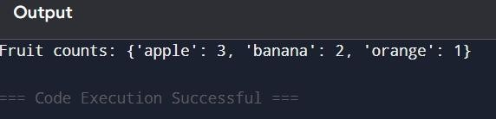
Ques 11 Given a list of tuples of students =[(‘alice’, 85),(‘bob’,90),(‘charlie’,78)], write a programme to print the name of the student with the highest marks.
# Given list of students with marks
students = [('alice', 85), ('bob', 90), ('charlie', 78)]

# Find the student with the highest marks top_student = max(students, key=lambda x: x[1])

# Print the name
print("Student with the highest marks:", top_student[0])
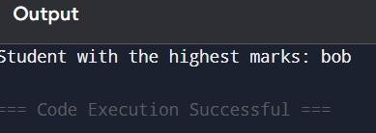
Ques 12 Given a list no =[1,2,3,4,5],create a dictionary where the key is the no and value is the cube of the number.
# Given list no = [1, 2, 3, 4, 5]

# Create dictionary with number as key and cube as value cube_dict = {x: x**3 for x in no}

# Print the dictionary
print("Cube dictionary:", cube_dict)
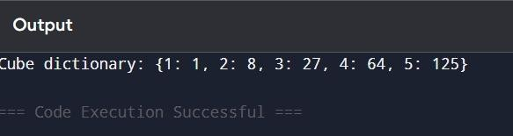
Ques 13 Write a python programme that accepts integer (n)and computes the value of n+nn+nnn
n = input("Enter an integer: ")

# Form nn and nnn by repeating the string
nn = n * 2
nnn = n * 3

# Convert them back to integers and add
result = int(n) + int(nn) + int(nnn)

print("Result:", result
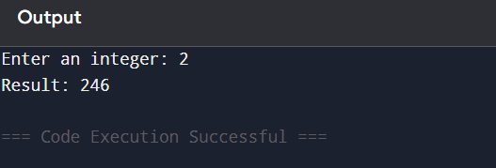
Ques 14 write a python programme to calculate the sum of three given numbers , if the value are equal then return thrice sum.
# Take three numbers as input
a = int(input("Enter first number: "))
b = int(input("Enter second number: "))
c = int(input("Enter third number: "))

# Calculate the sum
total = a + b + c

# Check if all three numbers are equal
if a == b == c:
total = total * 3

print("Result:", total)
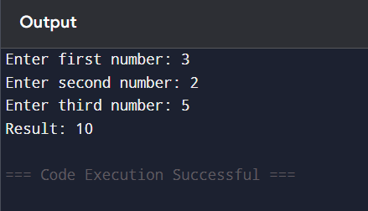
Ques 15 Generate a random number between 1 and 9 (including 1 and 9).ask the user to guess the number ,then tell them whether they guessed to low ,too high ,or exactly right.
import random

# Generate random number between 1 and 9
number = random.randint(1, 9)

# Ask user to guess
guess = int(input("Guess a number between 1 and 9: "))

# Check the guess
if guess < number:
print("Too low!")
elif guess > number:
print("Too high!")
else:
print("Exactly right! 🎉")
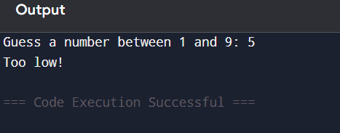
Ques 16 Implement a function that takes an input three variables ,and returns the largest of the three . do this without using the python max() function!
def largest(a, b, c):
if a >= b and a >= c:
return a
elif b >= a and b >= c:
return b
else:
return c

# Example use:
x = int(input("Enter first number: "))
y = int(input("Enter second number: "))
z = int(input("Enter third number: "))

print("The largest number is:", largest(x, y, z))
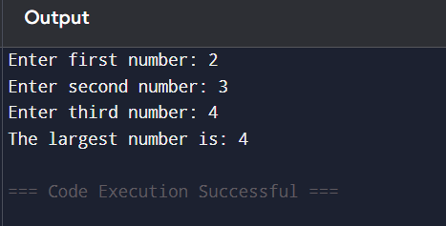
Ques 17 write a very easy python programme to perform read and write operations on a file.
file = open("testfile.txt", "w")
file.write("This is a test file.\n")
file.write("Writing to a file in Python.\n")
file.close()

# Read from the same file
file = open("testfile.txt", "r")
content = file.read()
file.close()

print("File content:")
print(content)

ques 18 write a programme that accepts date of birth along with the other personal details of a person.throw an exception if an invalid date is entered.
from datetime import datetime

try:
name = input("Enter your name: ")
age = input("Enter your age: ")
dob = input("Enter your date of birth (DD-MM-YYYY): ")

# Validate the date
valid_date = datetime.strptime(dob, "%d-%m-%Y")

print("\n--- Personal Details ---")
print("Name:", name)
print("Age:", age)
print("Date of Birth:", dob)

except ValueError:
print("Error: Invalid date entered! Please use DD-MM-YYYY format.")

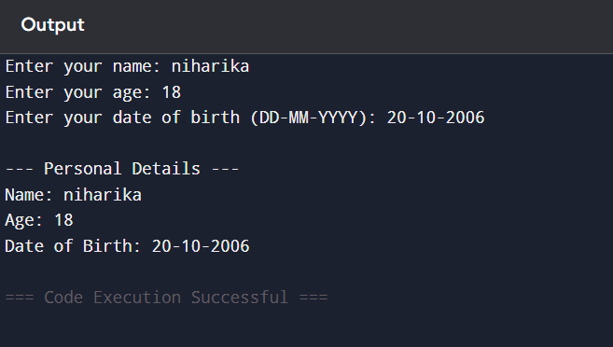
Ques 19 Write a regular expression to represent all 10 digits mobile numbers . Rules 1 . Every number should contains exactly 10 digits
2. The first digit should be 7 or 8 or 9 . write a python programme to acheck whether the given no is valid mobile number or not?
import re

# Regular expression for a valid 10-digit mobile number
pattern = r'^[789]\d{9}$'

# Take mobile number input from the user
mobile = input("Enter a 10-digit mobile number: ")

# Check if the mobile number matches the pattern
if re.fullmatch(pattern, mobile):
print("Valid mobile number ✅")
else:
print("Invalid mobile number ❌")
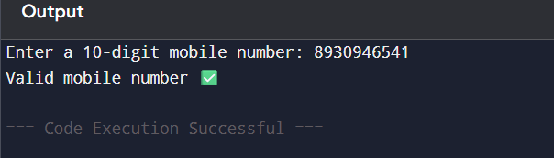
Ques 20 Write a function that takes an ordered list of numbers ( a list where the elements are in order from smallest to largest) and another number . the function decided whether or not the given number and inside the list in and returns (then prints) an apporiate Boolean.
def is_number_in_list(ordered_list, number):
"""
Checks if a number is present in an ordered list.
Returns True if present, False otherwise.
"""
# Since the list is ordered, we could use binary search for efficiency,
# but here we use a simple approach for clarity.
if number in ordered_list:
return True
else:
return False

# Example usage
my_list = [1, 3, 5, 7, 9, 11]
num = int(input("Enter a number to check: "))

result = is_number_in_list(my_list, num)
print("Is the number in the list?", result)
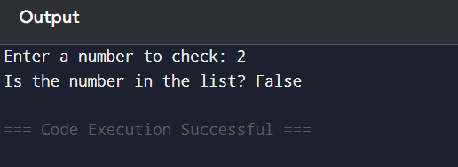
Ques 21 A fitness coach wants to analyze the BMI of a group of people to access their health status. The data includes the name, age,weight (kg),and height(m)of each person . the coach wants
To calculate BMI foe each person
To categorize each person based on their BMI
To get a summary of how many people fall into each category.
to calculate BMI
def calculate_bmi(weight, height):
return weight / (height ** 2)

# Function to categorize BMI
def bmi_category(bmi):
if bmi < 18.5:
return "Underweight"
elif 18.5 <= bmi < 25:
return "Normal weight"
elif 25 <= bmi < 30:
return "Overweight"
else:
return "Obese"

# List to store people's data
people = []

# Example data (name, age, weight in kg, height in m)
people.append({"name": "Alice", "age": 25, "weight": 55, "height": 1.65})
people.append({"name": "Bob", "age": 30, "weight": 85, "height": 1.75})
people.append({"name": "Charlie", "age": 22, "weight": 68, "height": 1.70})
people.append({"name": "David", "age": 28, "weight": 50, "height": 1.60})

# Dictionary to store category summary
summary = {"Underweight": 0, "Normal weight": 0, "Overweight": 0, "Obese": 0}

# Calculate BMI and categorize each person
for person in people:
bmi = calculate_bmi(person["weight"], person["height"])
category = bmi_category(bmi)
person["bmi"] = round(bmi, 2)
person["category"] = category
summary[category] += 1

# Print BMI details of each person
print("BMI Details:")
for person in people:
print(f"{person['name']} (Age {person['age']}): BMI = {person['bmi']}, Category = {person['category']}")

# Print summary
print("\nSummary:")
for cat, count in summary.items():
print(f"{cat}: {count} person(s)")

QUES 22 Take a list , say example this one a=[1,2,3,5,8,13,21,34,55,89] and write a program that prints out all the elements of the list that are less than 5.
a = [1, 2, 3, 5, 8, 13, 21, 34, 55, 89]

for item in a:
if item < 5:
print(item)
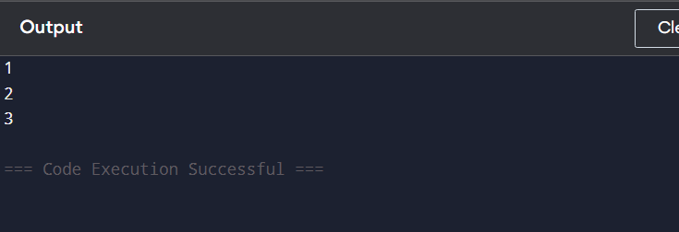
QUES 23 Take two lists , say for example these two:
a=[1,2,3,5,8,13,21,34,55,89]
b=[1,2,3,4,5,6,7,8,9,10,11,12,13]
and write a programme that returns a lists that contains only the elements that are common between the lists (without duplicates).make sure that your programme works on two lists of different sizes.
a = [1, 2, 3, 5, 8, 13, 21, 34, 55, 89]
b = [1, 2, 3, 4, 5, 6, 7, 8, 9, 10, 11, 12, 13]

# Using a set to avoid duplicates
common = list(set(a) & set(b))

print(common)
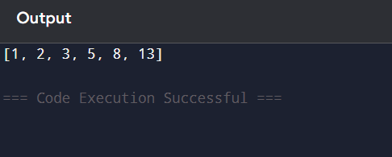
Ques 24 Write a python programme (function) that takes a lists and returns
A new list that contains all the elements of the first list minus all the duplicates .
def remove_duplicates(lst):
new_list = []
for item in lst:
if item not in new_list:
new_list.append(item)
return new_list
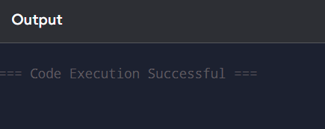
Ques 25 Create a programme that asks user for a number and then prints out a list of all the divisors of that number .(if you don’t know what a divisor is,it is a number that divides evenly into another number. For eg 13 is a divisor of 26 because 26/13 has no remainder.)
num = int(input("Enter a number: "))

divisors = []

for i in range(1, num + 1):
if num % i == 0:
divisors.append(i)

print("The divisors of", num, "are:", divisors)
